Yingjin Wang

ICA #4

1. How many restaurants with stars?

SELECT stars, count(business_name) as number_restaurants

FROM yingjin.yelp_reviews

WHERE stars <> '?'

group BY 1

ORDER BY stars

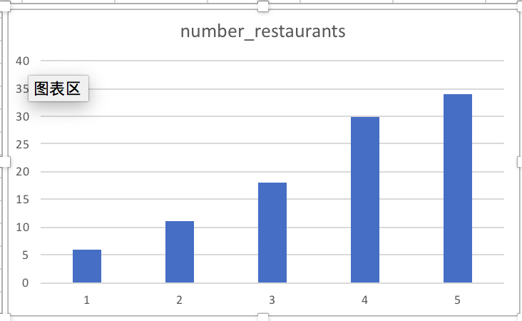

1. How many check-ins during Monday to Friday?

SELECT weekday, count(checkins) as number_checkins

FROM datasets.yelp_checkin

group BY 1

ORDER BY weekday

1. Count during January 2016 the amount of reviews of users reviews above 300?

SELECT name, review_count

FROM datasets.yelp_user

where yelping_since between '2016-01-01' and '2016-01-31'

and review_count > 300

group BY 1,2

ORDER BY review_count DESC

1. What’s the useful reviews in times?

SELECT useful, count(review_id) as count_useful

FROM datasets.yelp_reviews

group BY 1

ORDER BY useful

1. How many cool reviews for the business with stars?

SELECT stars, count(cool) as count_cool

FROM datasets.yelp_reviews

group BY 1

ORDER BY stars